CMT206 Human Centric computing

Coursework part 1

Contents

Application and User Description 2

Task Analysis 3

STN1 for use case1 6

STN2 for case 2 6

Interface Prototype 6

Alternative design 19

References 24

## Application and User Description

An increasing number of commuters use mobile applications to buy tickets for public transportation. An interesting study of commuters in major American cities such as Boston and San Francisco found people are more willing to ride the bus or train when they have effective tools to manage their commutes through apps providing real-time information about transit schedules, delays and other services along the routes.

The primary functions of this application will be:

* To select users location: typing or using google maps
* Select destination location: typing or using google maps
* Select means of transport: Bus or Train
* View available routes of selected destination
* Find nearby stops using user’s location using google maps
* And checking how often the bus or train leaves the station.

**Persona**

**James Alden**

The persona is between 30 – 35 years old. He is a salesman and spends too much time in the road commuting into the city. James specifically wants to:

* Save time from buying tickets at a bus or train ticket counter
* Find easily which bus or train needs to get
* Find when it departs
* Find how long is the journey
* And the nearest station

It is important to him that he uses an application which is effective at finding routes, stations and departure time, in order to schedule his time more effectively, because he has a lot of meetings every day around the city. It is necessary that he don’t miss any of his meetings.

## Task Analysis

**Use Case**

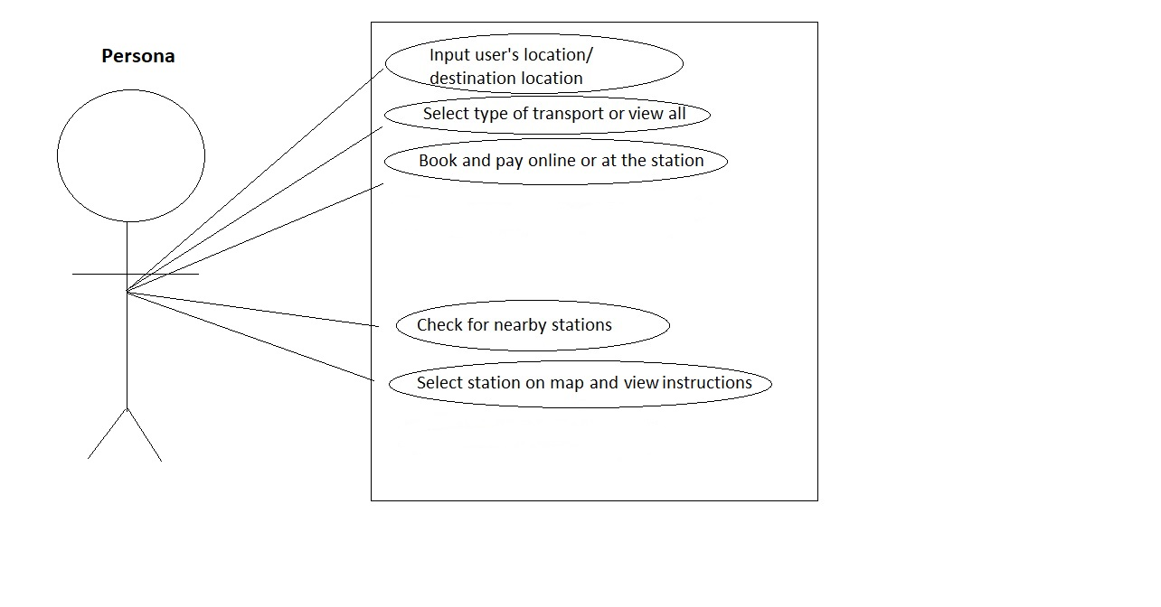

|  |  |  |  |  |
| --- | --- | --- | --- | --- |
| All  Of the time |  |  | Select type of transport or view all | Input User’s location/Input destination location |
| Most  Of the time |  |  | Check for nearby stations | Book and pay online or at the station |
| Some  Of the time | Log in | Select station on the map and view instructions |  |  |
| Very Little  Of the time | Save routes |  |  |  |
|  | Few  Of the  people | Some  Of the  people | Most  Of the  people | All  Of the  people |

|  |  |  |  |  |  |  |  |
| --- | --- | --- | --- | --- | --- | --- | --- |
| Use Case No: 1 | Use case name: Find destination and book ticket | | | | | Rating: Must have | |
| Purpose: Allow users to input their location and destination location | | | | | | | |
| Main Actors: User / Persona: James Alden | | | | | | Secondary actors: None | |
| Preconditions: Application is open and GPS is turned on | | | | | | | |
| Trigger: Click on location input and/or map | | | | | | | |
| Description:  Basic flow:  User should:  1. See the location inputs and be prompted to enter location or open the map  2. Select type or transport or click to see all  3. See transports timetable and price  4. Select transport time  5. Book  6. Pay    Alternative flow:  1. Book only and pay at the station  2. Cancel booking | | | | | | | |
| Extension: None | | | | | | | |
| Related Use cases: None | | | | | | | |
| Post conditions: New booking form downloaded to the user’s phone. It will be used from the user to pass check in | | | | | | | |
| Author:Vasilis Tompazis | | Date: 25/02/2018 | |  |  | |  |
|  | |  | |  |  |  |  |
|  | |  | |  |  |  |  |
| Use Case No: 2 | Use case name: Instructions to nearest station | | | | | Rating: Should have | |
| Purpose: Guide users to the nearest station | | | | | | | |
| Main Actors: User / Persona: James Alden | | | | | | Secondary actors: None | |
| Preconditions: Application is open and GPS is turned on | | | | | | | |
| Trigger: Click the “Find station near me” button | | | | | | | |
| Description:  Basic flow:  User should:  1. Click the “Stations” button  2. Select the nearest station on the map  3. See and follow instruction to the destination  Alternative flow:  1. Choose another station  2. Exit map | | | | | | | |
| Extension: None | | | | | | | |
| Related Use cases: None | | | | | | | |
| Post conditions: Instructions given to the user | | | | | | | |
| Author:Vasilis Tompazis | | Date: 25/02/2018 | |  |  | |  |
|  | |  | |  |  |  |  |
|  | |  | |  |  |  |  |
|  |  | |  | |  |  |  |
|  |  | |  | |  |  |  |

## STN1 for use case1

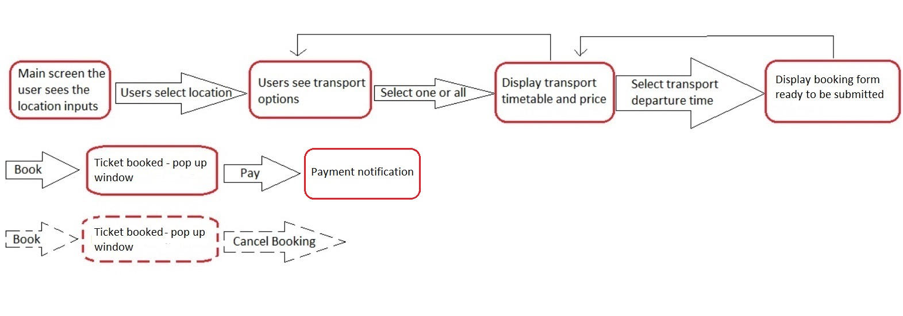

## STN2 for use case 2

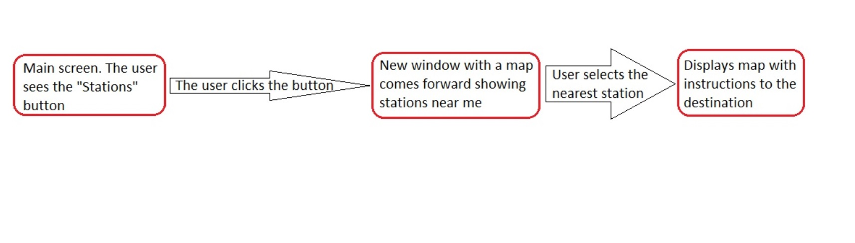

## Interface Prototype

**Designing for Android Smartphones**

The following design patterns follow the general heuristics and usability principles and also the latest Android design guidelines and Google’s guidelines at materialdesign.io (2018).

**Errors**

The application has been designed in mind for error prevention.

In the Use case 1: the user must type a destination in order to get results in the text input and click one of the them to move to the “Transport options” page. The same applies for the “Choose on map” function. No errors can be made as there are no options for input aside from clicking buttons.

In the Use case 2: the user just has to select one of the stations on the map and receive instructions. Again no errors can be made as there are no options for input aside from clicking buttons.

**Use case 1: Find destination and book ticket**

|  |  |  |
| --- | --- | --- |
| 1. **From the main menu User selects the search bar or the map to find destination** | | |
| **Use case 1: state 1, screen 1: Main page** | 1. Android Search bar to find destination. 2. Icon for alternative search on map. 3. Favorites categories. 4. Category of recent journeys.   **Organizational system:**  Location  Alphabet  **Time**  Category  Hierarchy   1. Bottom navigation bar according to **material design.**     **Usability Principles 2:** Match between system and real world  **Usability Principles 4:** Consistency and standards  **Usability Principles 6:** Error prevention  **Usability Principles 9:** Aesthetic and minimalist design | The system speaks the user’s language with words, phrases familiar to the user. The information appears in a natural and logical order. The search bar uses a simple language asking the user where he wants to go (what is his final destination). Then the “choose on map” icon follows allowing the user to find his destination on the map. The rest of the content has simple language.  The design is consistent using distinct colors for icons, text and categories, so the user can easily distinguish what he icon or button has to click in order to achieve a certain result. The design follows the Google’s **material design**, as we can see from:   * Search bar * Bottom navigation bar * Back button * Single menu item states(3 vertical dots)   Elements of each category of the content have equal distance following platforms standards. There is also a bottom navigation bar which the user can use it to navigate easily to other pages of interest.  Everything in the page is aligned adhering to the “aesthetic and minimalist design” principle.  The “Recent Journeys” category is organized automatically by time |
|  | | |
| **Use case 1: state 2, screen 2: User selects location/destination** | 1. Android search bar and auto complete. 2. Android keyboard. 3. Back button following material design style.   **Usability Principles 3:** User control and freedom  **Usability Principles 4:** Consistency and standards  **Usability Principles 6:** Error prevention  **Usability Principles 8:** Flexibility and efficiency of use | At this stage user can always press the back button to exit and return to the main screen.  The system is consistent using the platform’s guidelines: android auto complete and keyboard.  It is not possible for the user to trigger any error, because with the auto completion whatever he types he gets some sort of result and if he doesn’t type anything there is no button that can trigger an error. There is only the back button.  The system is efficient and fast as the auto completion helps user to find relevant results without having to type the whole text. |
|  |  |  |
| **Alternative flow:**  **Use case 1: state 2, screen 3: User selects location/destination on map** | 1. Give instruction to the user. 2. Map. 3. Text displaying the location/destination the user selected. 4. “OK” button. 5. Back button   **Usability Principles 2:** Match between system and real world  **Usability Principles 3:** User control and freedom  **Usability Principles 4:** Consistency and standards  **Usability Principles 6:** Error prevention    **Usability Principles 8:** Flexibility and efficiency of use  **Usability Principles 9:** Aesthetic and minimalist design | The system gives instruction that the user needs to move the map to find his destination.  At this stage user can always press the back button to exit and return to the main screen.  The system is consistent using the same colors and patterns in all pages of the application.  There is also error prevention because the map always points a location on the map, so If the user clicks the button he will always get a result.  The system is fast and efficient because while the user is pointing a spot on the map, automatically generates a text with the current destination under the map.  Everything in the page is aligned adhering to the “aesthetic and minimalist design” principle. |
| **Use case 1: state 3, screen 4: Displaying transport options/timetable** | 1. Inputs that display the start point of the user’s current location and final destination at the top of the screen. 2. Three buttons to choose transport options. 3. Text that displays the todays date and an icon the user can change the date. 4. A grid of icons and text that display the timetable of all the transports. 5. Again the bottom navigation bar. 6. Back button   **Usability Principles 2:** Match between system and real world  **Usability Principles 3:** User control and freedom  **Usability Principles 4:** Consistency and standards  **Usability Principles 6:** Error prevention  **Usability Principles 7:** Recognition rather recall  **Usability Principles 9:** Aesthetic and minimalist design  **Organizational system:**  Location  Alphabet  **Time**  Category  Hierarchy | The system uses simple language informing the user for his current location and final destination and as well for the timetable and prices.  There three buttons aligned horizontally allowing the user to change transport options. The default is “ALL”. The user can always press the back button or the “Home” at the bottom navigation bar to exit and return to the main screen. So the user is always one click from the main page.  The colors are consistent following the same pattern and the buttons are visible to the user.  The system doesn’t allow any errors as the buttons change only the state of the app.  It is clear to the user what he needs to do in order to change the state of the app and move forward to the next step. The 3 buttons indicate what the user should click in order to change type of transport. Also the green circle arrows point out that if the user clicks them automatically selects the certain ticket.  Everything in the page is aligned adhering to the “aesthetic and minimalist design” principle. The time table is a grid layout.  The timetable is organized by time. |
| **Use case 1: state 3, screen 5: Displaying transport options/timetable (Train)** | The design here is the same as the previous page, following the same principles. |  |
| **Use case 1: state 4, screen 6: Display departure time and price. (of certain transport.)** | 1. Text displaying booking form 2. Buttons to submit or cancel the booking 3. Bottom navigation bar 4. Android Back button   **Usability Principles 3:** User control and freedom. Need a clearly marked “emergency exit”  **Usability Principles 6:** Error prevention  **Usability Principles 9:** Aesthetic and minimalist design | The user can at any moment cancel the booking and return back to the previous page or click the home button to return “Home”.  It is no possible for the user to trigger any errors as there are only 2 buttons to book or cancel the booking, and the links of the bottom navigation bar.  Everything in the page is aligned adhering to the “aesthetic and minimalist design” principle. |
| **Use case 1: state 5, screen 7: Ticket booked – Pop up window.** | 1. Pop up window informing user that the ticket is booked and he can pay now.   **Usability principle 1:**  Visibility of system status  **Usability Principles 3:** User control and freedom. Need a clearly marked “emergency exit”  **Usability Principles 8:** Flexibility and efficiency of use | The pop up appears after the user has clicked the book button, so it can be noticeable what the user has to do. It informs user that can pay now or cancel the payment and receive the ticket at the station.  The user always can cancel payment and return back.  The user is **flexible** to choose to pay now using credit card or by cash at the station |
| **Use case 1: state 6, screen 8: Payment notification** | 1. Notification informing user that the “Ticket Paid”.   **Usability principle 1:**  Visibility of system status  **Usability Principles 2:** Match between system and real world | A notification appears informing the user about the ticket payment and the amount that he paid. The notification disappears after a few seconds.  The message is in a simple and concise language following Nielsen’s heuristics #2. |
| **Use case 2: state 1, screen 1: Main screen – The user sees the “Stations” button (and clicks it)** | Main page of the app as the use case 1 - state 1. |  |
| **Use case 2: state 2, screen 2: A map comes forward.** | 1. A header informing the user what the status. 2. Below there is another header telling the user what he needs to do. 3. A map to navigate in order to find the station. 4. Bottom navigation bar. 5. Back button   **Usability principle 1:**  Visibility of system status  **Usability Principles 2:** Match between system and real world  **Usability Principles 3:** User control and freedom. Need a clearly marked “emergency exit”  **Usability Principles 6:** Error prevention | The user is informed about his status.  The system gives instructions to the user needs to do in order to find the station on the map.  The user can return to the main menu by clicking the “Back” button or “Home” in the bottom navigation bar. So he is always one click away.  There are no possible errors, as there are no inputs and buttons to trigger errors. The user is just moving the map to find location. |
| **Use case 2: state 3, screen 3: Displays map with instructions to the destination** | 1. The page is the same as the previous one. Here the app is displaying the route the user needs to follow in order to reach his destination. 2. Bellow the map the app shows a text with the station and the distance of the current user’s location.   **Usability Principles 8:** Flexibility and efficiency of use | The user once he finds the station on the map, he just clicks the icon on the map and the system automatically displays the route he needs to follow on the map and the name of the station with the distance walk. There are no extra buttons and is easy to use and efficient. |

### Alternative Design

|  |  |
| --- | --- |
| **Use case #1: Main page**    **Choose destination** | This design also follows the Android’s material design guidelines and Nielsen’s heuristics.  In the alternative design the colors are the same as the previous design. However the layout is different and the application has fewer phases to display the desired results to the user.  This is the main screen. The user has most of the functions in the main screen so he doesn’t have to navigate the app and change too many pages to find information. The search bar and the transport options are together on the top of the screen in the orange background so they can be easily seen and found by the user.  Below those 2 is the map which is the second alternative way to find destination. The app gives freedom and flexibility to the user to choose between 2 options.  Below the map there are “Places” most used by the user, so he can find them faster.  This is the main screen. When the user clicks the search bar a drop down appears so the user can select a destination with the help of the auto completion. The user doesn’t have to move to new page which it reduces the number of steps he needs to do.  The app is carefully designed to avoid errors. The user has to type a destination to get results, otherwise nothing will happen.  The design is the same as the above. |
| **Use case #1: Transport options and timetable**    **Book Ticket** | This is again the main page. The user after he chooses the destination a pop up window appears in red background with white letters to create contrast so it can be noticeable and readable by the user.  Again the user doesn’t have to leave the page so he just needs to click the back button if he wants to display the whole main page.  Everything in the timetable content is aligned adhering to the “aesthetic and minimalist design” principle and is written in clear and concise way.    After the user clicks the selects the desired ticket the pop up window changes and displays, without moving from the main page, only the ticket the user selected, with 2 buttons. The layout and the styling remains the same. It is visible to the user that there are 2 options to book ticket or cancel. |
| **Use case #1: Payment**    **Payment Message** | After the user clicks the book button a pop up window appears informing the user what needs to be done to proceed to the next step. The Pop up box is shaded a different color. This is mainly because it will draw the eyes to the message.  After the user clicks the payment button a message appears on the screen under the ticket information, and informs the user that the payment is done. It is in a green box, so it can make a contrast and be visible to the user. |
| **Use case # 2: Find stations- Main page**    **Show stations** | Main page as in the Use case 1.  The user after he clicks the “Stations” button on the menu bar, he moves to a new screen with a map showing nearby stations using user’s location. The layout and colors follow the system’s pattern. In the orange box under the menu bar the user is being informed that he needs to find a station. The stations appear in a blue color. No errors can be triggered as there are no inputs or buttons, the user has only to click the icon on the map and the system automatically will display the instructions to the user which also makes it efficient and fast. The use is only one click away to exit and return to the main menu. There is also at the bottom of the page a link with the visited stations so the user can speed up the process if he wants to find a station that he has already visited. |
| **Show instructions** | The user after he clicks the icon he wants, a pop up window shows up with written and map directions. So it can be easy for the user to navigate and choose which one wants to use. Everything in the written directions content is aligned adhering to the “aesthetic and minimalist design” principle and is written in clear and concise way. |

### References

Nielsen Norman Group (1995) 10 Heuristics for user interface design: Article by Jakob Nielsen. Available at: <https://www.nngroup.com/articles/ten-usability-heuristics/> (Accessed: 1 March 2018)

Material Design (2018) Available at: <https://material.io/> (Accessed: 25 February 2018).

Android Developer: <https://developer.android.com/design/get-started/principles.html> (Accessed: 25 February 2018)

# Top 10 transport apps for smarter travel: Article by Stuart Dredge. Available at: <https://www.theguardian.com/public-leaders-network/2016/sep/15/top-10-transport-apps-smarter-travel>